Module: Accounts Payable
Topic: AP Invoice Processing
AP Invoice Entry Version 10 and Higher

Objective
This document provides step-by-step instructions on how to enter an invoice into MUNIS. This document is intended for Intermediate MUNIS users that already have a basic knowledge of the MUNIS Invoice Entry process.

Overview
When you choose to enter an invoice into MUNIS, you are requesting that funds be set aside to pay for items already purchased or for services that will be provided in the future. After the invoice is entered, funds are set aside in the GL account. Once the invoice has gone through the approval process, the necessary steps can be completed to create a check to be sent to the Vendor to pay for goods or services rendered.

Prerequisites
Before you can successfully use this feature, you must ensure that the necessary settings and codes are in place. If settings and codes are not set up, or not set up correctly, you may need to contact your MUNIS System Administrator or Department Manager to have them updated or added into the MUNIS system.
- Vendor that you wish to pay must exist in Vendor File Maintenance
- AP Settings must be completed
- Cash account and Accounts Payable account must exist in the General Ledger
- Need invoice number and other information regarding purchase
- GL account to be charged for this invoice

Procedure
Use the following steps to…:
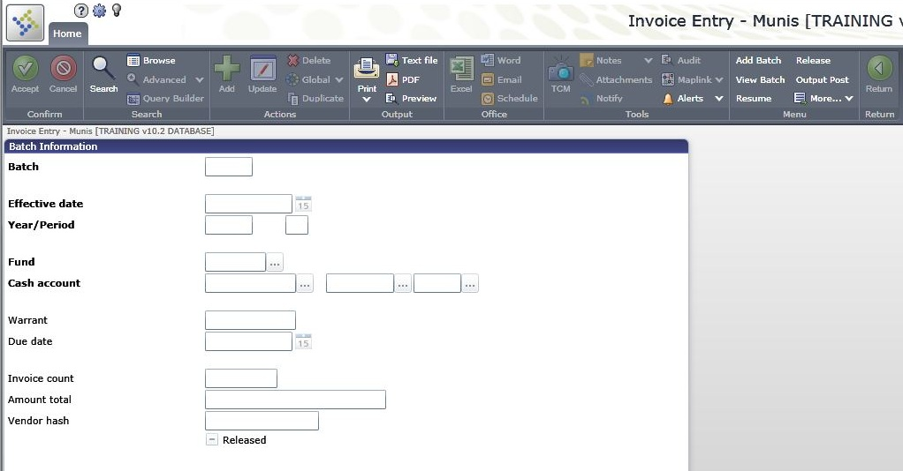
- Open the AP Invoice Entry/Proof program.
Financials > Accounts Payable > Invoice Processing Menu > Invoice Entry/Proof

- On the MUNIS Ribbon, click Add Batch.
- Enter the following for the fields in order to complete the batch header…
Field | Description
Batch | This is a number assigned to identify the batch.  The system assigns this number according to the default value in AP Settings, but you can change this.  After a batch is posted, the batch number may be reused.  The Batch box is only accessible when you are adding a new batch.
Fund | This is the fund to be used with this batch.  The default value for the fund is the fund established in AP Settings, but you can change this. However, before changing a default fund value, verify that your new selection is valid by contacting the appropriate financial contact for your organization.  Expense accounts may be outside of this fund; MUNIS programs make due to/due from entries using the balance sheet accounts in Due To/Due From FM when the Cash Disbursements Journal is posted.
Cash Account | This is the cash account used to pay invoices entered in a batch.  The account that initially appears in the field is retrieved from Fund Attributes FM on the General Ledger Set Up/Chart of Accounts menu when you enter data into the Fund box. You can change this here, or on an invoice-by-invoice basis during Invoice Entry/Proof. However, before changing a default cash account value, verify that your new selection is valid by contacting the appropriate financial contact for your organization.  You can use the same check number for multiple wire transfers within the same batch. For this to occur, the Cash Account, Warrant, Vendor, and Check/Wire Date fields must be the same for every invoice with the same check number. When the invoices are posted, one cash disbursement record is created for every invoice with the same wire number.  If your organization uses the full account entry method, you must enter the full general ledger account number; if your organization uses the org/object account entry method, enter the org code, object code, and project code (if applicable).
Warrant (Check Run) | This is the warrant number assigned to invoices in the batch.  The warrant number can be up to eight alphanumeric characters.  The warrant number is optional.
Due Date | This is the due date for the invoices in the batch.  The due date becomes the key for selecting invoices to be paid on a specific check run when the warrant number is blank.  The default value for the due date is the date that the invoice is entered.
Effective Date | This is the date the invoice affects the general ledger.  The default value in this date is the current date, but you can change this.
Year/Period | This is the fiscal year and period for the batch.  The default values originate in GL Settings for all invoices entered into the batch. However, you can change this on the header of any invoice if you have appropriate permissions.  The year may be the current, next, or last year if general ledger year-end closing has occurred.  If you enter last year, the program automatically enters period 13.
Enable TCM Invoice Barcode Label Printing | This check box directs the program to print Tyler Content Manager barcode labels on the invoice.
Invoice Count | This is the total number of invoices in the current batch.
Amount Total | This is the total amount of all invoices in the batch.  The total amount is display only.
Vendor Hash | All vendor numbers are added together to produce a hash total, which may be used as a control number when entering a batch of invoices. By manually adding vendor numbers to all invoices and comparing that number to the vendor hash, invoices missing from the batch can be detected.

- Tab to go to the next screen:

The invoice entry screen in divided into two parts, the header and detail screen. This is the invoice header. The header contains information pertaining to the entire invoice while the detail screen contains information regarding the GL account number and amounts.
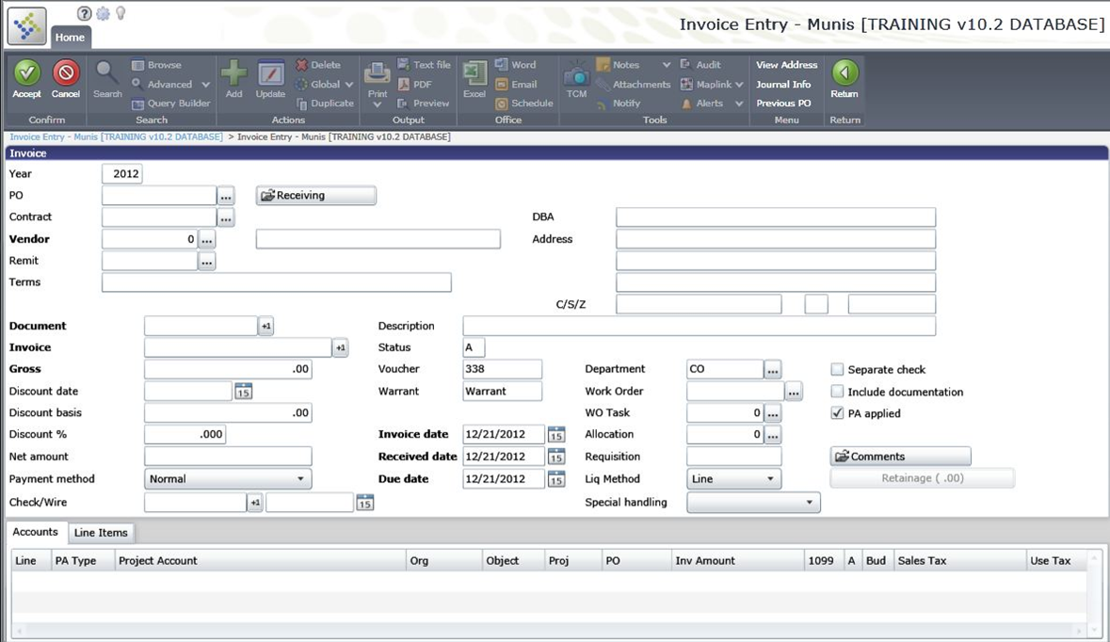

Complete the following fields in order to complete the invoice header:
Field | Action or Description
Year | Enter the Fiscal Year for the Invoice. The default is the current year.
PO | Enter the desired Purchase Order to liquidate or click to see a list of Purchase Orders.
Vendor | Enter the desired vendor number or click to search for a vendor
Remit | Enter the number for the vendors remit address or click to see a list
Document | Defaults based on AP Settings or click +1 to retrieve next number
Invoice | Enter Invoice number or click +1 to retrieve the number
Gross Amount | Enter the gross amount of the invoice
Discount Date | Enter the date (or click calendar) invoice must be paid to receive discount
Discount Basis | Enter the amount of invoice that is subject to discount
Discount percent | Enter the percentage amount for the discount, defaults from Vendor file
Net Amount | Gross Amount of invoice less any discounts
Payment Method | Defaults to Normal
Description | Enter a brief description of the items or services purchased
Status | Defaults based on workflow set up in AP Settings
Voucher | Defaults based on set up of AP Settings
Warrant (Check Run) | Defaults from AP batch header
Invoice Date | Enter the date from the invoice or click on calendar
Due Date | Defaults from batch header or may be changed
Dept/Loc | Enter department code or click on
Work Order | Enter work order number of click to see list (if applicable)
Alloc | Enter allocation code or click to see list (if applicable)
Req | No access, will reflect requisition number if applicable
Liq Method | Liquidation Method, defaults from AP parameter table
Separate Check | Check if a separate check is desired for this invoice
Inc Documentation | Check if documentation is to be mailed with this check
PA applied | Check if a project accounts are applied to this transaction.
Comments | Click on Comments button to add notes regarding invoice

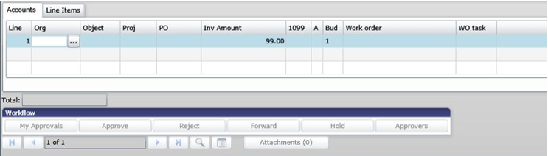
- Tab to go to bottom section of screen:

- Enter desired GL account code or click to see list of accounts.
- Enter invoice amount to be charged to this account code.
- If appropriate, 1099 code will default, based upon permissions, this may be changed
- If applicable, enter Fixed Asset code here
- 1 indicates Current budget, 2 indicates Carry Forward budget
- After all information is complete Click OK/Accept 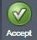 or press enter to save the invoice entry line.
- Exit the Line Detail screen by selecting Return from the Ribbon. 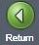 This will take you out of the line detail back to the main invoice entry batch header information.
- You may then click on Release option in the Menu on the Ribbon to release the batch for posting
- Click on Approvals under More Options in the Menu on the Ribbon to initiate approvals if workflow exists.

Results

Status Change
With workflow, a released invoice batch will have a status of H – Held. You can click on the Approvers button on each individual invoice to see who needs to approve the invoice.
Without workflow, your invoice is now approved and will have a status of A - Approved
If there is a status change to the record or an associated table, describe it here.

GL Impact
The GL account will now show the invoice amount (in the Actual (Memo) field) which reduces the Available Budget amount. A posted invoice will debit the Expenditure account and Credit Accounts Payable.

Other Munis Modules Impact
There is no impact on other MUNIS modules by this action.

What’s Next?
With Workflow, the invoice is waiting on approval.
Without Workflow, the approved invoice is output posted and a check is printed using the MUNIS Cash Disbursements process.

