Module: Accounts Payable
Topic: Credit Memos
Entering Accounts Payable Credit Memos Munis Version 11.2

Objective
This document is intended to provide step by step instructions on how to enter and process a credit memo in the Munis Accounts Payable module.

Overview
In Munis, credit memos are entered into the Invoice Entry program in the Accounts Payable module. Credit memos are entered with negative amounts, and are posted like regular invoices. A credit memo will remain in the Select Items to be Paid program until an invoice for the same vendor is processed. Munis will deduct the credit memo amount from the amount to be paid on the invoice, and any remaining amounts will stay open on the credit memo until the next invoice is entered. Once the entire credit has been applied, the credit memo will be automatically removed from the Select Items to Be Paid program.

Prerequisites
Before you can successfully use this feature, you must ensure that the necessary settings and codes are in place. If settings and codes are not set up, or not set up correctly, you may need to contact your Munis system administrator or department manager to have them updated or added into the Munis system.

- Accounts Payable settings must be defined
  - Make sure all settings are defined under Financials > Accounts Payable > Setup > Accounts Payable Settings
- You have access to the Accounts Payable Invoice Entry program under Financials > Accounts Payable > Invoice Processing > Invoice Entry
- The vendor that you wish to pay must exist in the Vendor Master.
- Cash account and Accounts Payable account must exist in the General Ledger.
- GL account to be charged must exist in General Ledger.
- If the credit memo is entered against the original invoice, this must be a valid invoice number in Munis, and the original invoice must have been posted and paid, and the cash disbursements journal must have been posted.
- If the credit memo is entered against the original invoice, but should be posted to a different GL account, you must have permissions to override credit memo defaults on your role permissions.
- If the credit memo is not entered against an original invoice, under your role permissions, you must have permission to enter credit memos without the original invoice.

Procedure
To enter a credit memo:

- Open the Invoice Entry program. Financials > Accounts Payable > Invoice Processing > Invoice
Entry.

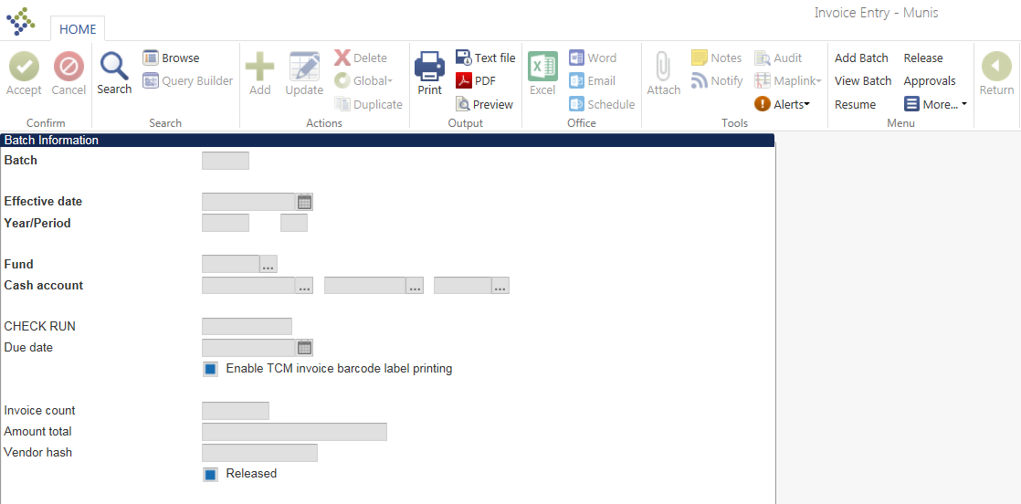
- On the toolbar, click Add Batch.
- Fill out the fields as specified below:

Field | Description
Batch | This is a number assigned to identify the batch. The system assigns this number according to the default value in the Accounts Payable settings, but this can be overridden. The Batch box is only accessible when you are adding a new batch.
Effective date | This is the date the invoices affect the General Ledger. The effective date defaults to today’s date but can be overridden.
Year/Period | This is the fiscal year and period of the invoice batch. The year and period default from the General Ledger settings, but can be overridden with the appropriate permissions.
Fund | This is the fund that the default cash account for AP invoices is located in. The system will default the fund from the Accounts Payable settings, but this can be overridden.
Cash account | This is the default cash account that is used on all invoices. The system will default the cash account from the default cash account in the Accounts Payable settings, but it can be overridden.
Check Run | This is the warrant/group for the batch of invoices. The Check Run can be up to six alphanumeric characters.
Due date | This is the invoice due date. The system will default the date based on the days after invoice date to default as the due date that have been defined in the Accounts Payable settings.
Invoice Count | This is automatically populated by the system based on the number of invoices that have been added to the batch.
Amount total | This is the total amount across all invoices that have been added to the batch.
Vendor hash | This is the sum of all vendor numbers of all vendors that have been used on the invoices in the batch.
Released | This checkbox indicates whether or not a batch of invoices has been released.

- Tab through the last field on the batch header. The system will automatically open the Invoice Entry screen.

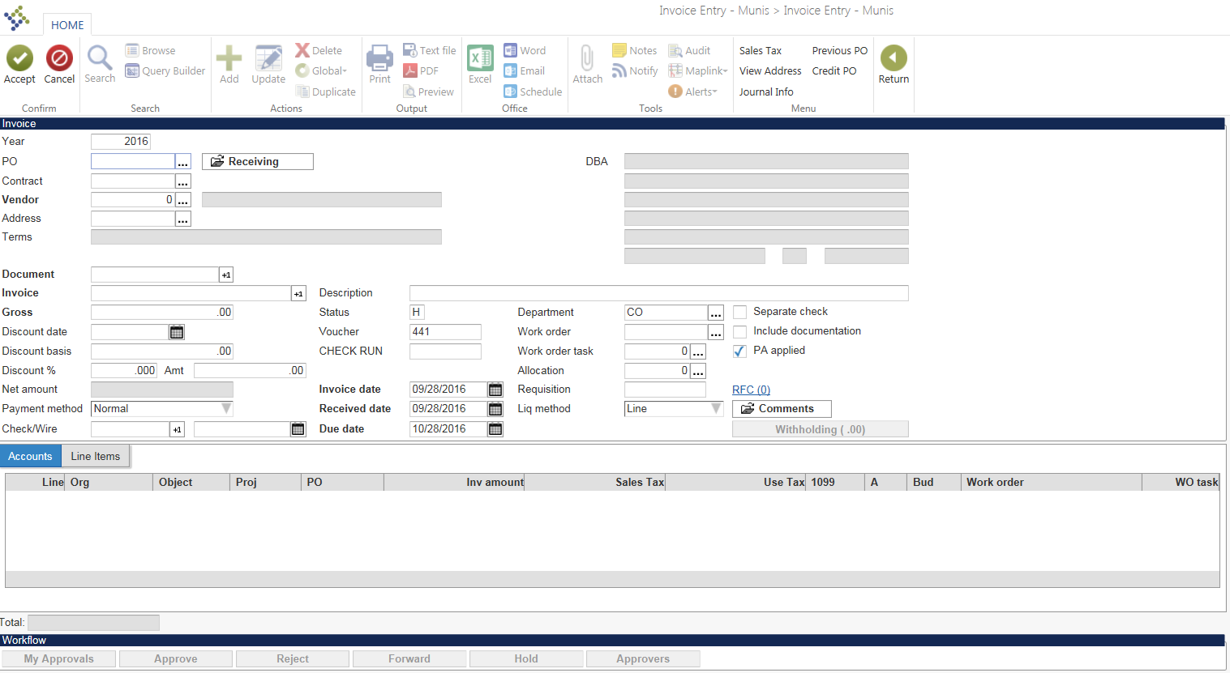

- Fill out the fields as described below:

Field | Description
Year | This defaults as the current fiscal year.
PO | Credit memos cannot liquidate PO’s. Therefore, this field must be left blank if a credit memo is entered.
Contract | Credit memos cannot liquidate contracts. Therefore, this field must be left blank if a credit memo is entered.
Vendor | Enter the vendor number that you want to add the credit memo for, or click on the field help button to browse all vendors.
Remit | If you would like to use a remit address for this vendor, click on the field help button and select the appropriate address. Otherwise, leave the default value of 0.
Address | This is the address of the vendor. It will default from the vendor master and based on your selection of the remit address.
Terms | These are the payment terms as defined on the vendor master. If no terms have been defined for this vendor, this field will be blank.
Document | This is the document number. The system automatically assigns the next sequential number, but this can be overridden.
Invoice | This is the invoice number.
Gross | Enter the amount of the credit memo here. Make sure to add a “- “sign in front of the amount to indicate that this is a credit memo. 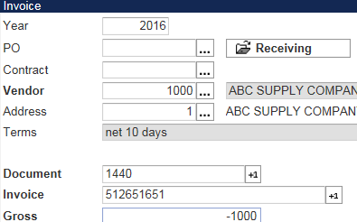

- The system opens up a new window. This window is intended to reference the original invoice number that the credit memo is entered against.

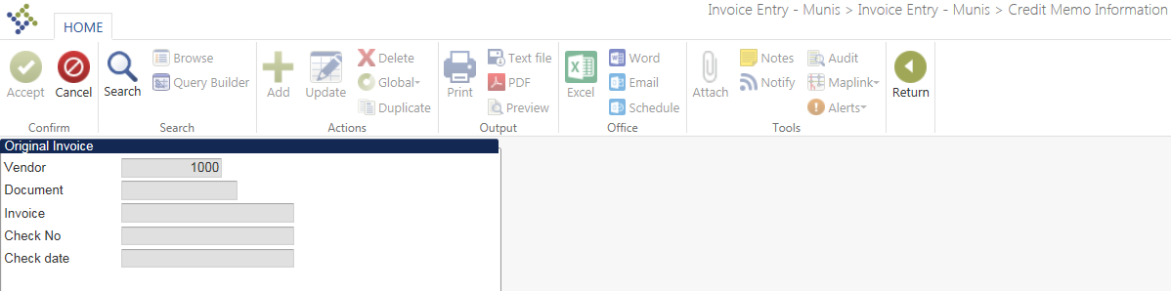
- If you do not want to enter the credit memo against an original invoice, click return .
If you are entering the credit memo against an original invoice in Munis, click on the magnifying glass and enter the original invoice number in the invoice field. You can also search for the original invoice by document number, check number, or check date.
- Click Accept .
- The system displays the invoice information.

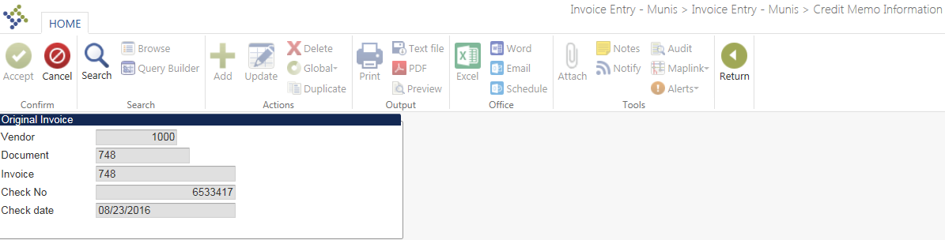

- Hit Return to return to the invoice entry screen.
- Resume entering the credit memo by filling out the fields as described below:

Field | Description
Payment Method | This defaults to the preferred payment method as defined on the vendor master, but can be changed.
Check/Wire | This field is only applicable if the payment method selected is direct disbursements or wire transfer.
Description | Enter a description for the credit memo here.
Status | This indicates the status of the invoice.
Voucher | Enter a voucher number, if applicable.
Check Run | This defaults to the check run number you entered on the batch header.
Invoice Date | This defaults to the invoice date you entered on the batch header.
Received Date | This will default to today’s date.
Due Date | This will default based on your Accounts Payable settings.
Department | Select the appropriate department, or leave this field blank.
Work Order | This is the work order number that invoices can be entered against. Leave this field blank for credit memos.
Work Order Task | This is the work order task number that invoices can be entered against. Leave this field blank for credit memos.
Allocation | If you are using allocation codes, you may select an allocation code. If the selected allocation contains GL accounts different than the GL accounts selected on the original invoice, then you must have permissions to override credit memo defaults. If you are not using allocation codes, leave this field blank.
Requisition | This is the requisition number that the PO that an invoice can be entered against was converted from. For credit memos, this field will be blank.
Liquidation Method | This is the default liquidation method that is defined in the Accounts Payable settings. This is not applicable for credit memos. Skip this field.
Separate Check | This indicates that a separate check should be printed for each invoice. Since no check will be printed for the credit memo, you can skip this field.
Include Documentation
PA applied | Check this field if the GL account that the credit memo is entered against is a project account.

- Tab through each field. The system will open the account allocation lines.

- If you are entering the credit memo against the original invoice, then the system will default the GL account that the original invoice was entered against as shown above.
- Click Accept to save the default GL account. If you have permissions to override credit memo defaults, you may also select a different GL account.
- Click Accept .

- Click Return to return to the invoice batch header. The system displays the credit memo information.
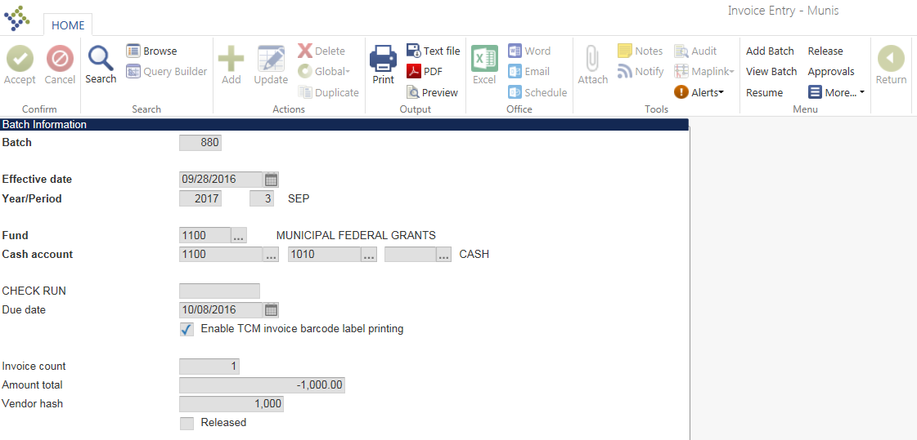

- Click Release. The release check box will be toggled.
- If your organization is using an approval workflow for AP Invoices, click on Approvers. This will initiate the approval process. After the credit memo has been approved, it may be posted.
- If there is no workflow for AP invoices, your invoice will be automatically approved. Click on output-post to post your credit memo.

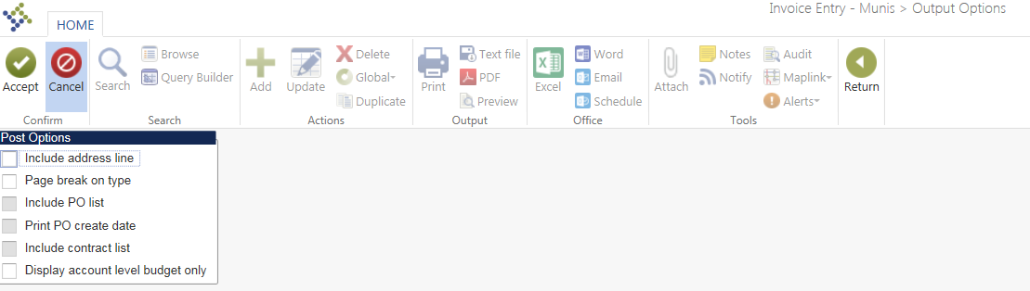

- Make the appropriate selections for your journal entry, and click Accept .

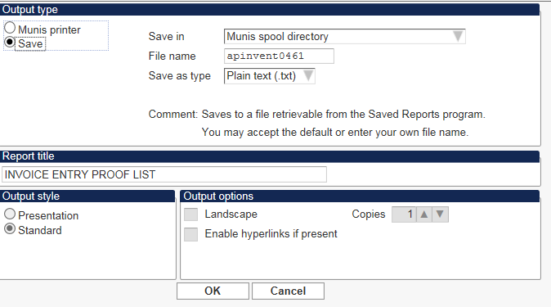

- Select Print or Save to print your journal proof report or save it to the spooled file.
- The system displays a confirmation message.

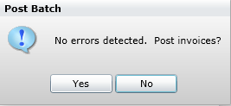

- Select Yes.
- Your credit memo has been posted.

- The credit memo is now located in the Select Items to Be Paid program.
- Go to Financials > Accounts Payable > Cash Disbursements > Select Items to Be Paid.

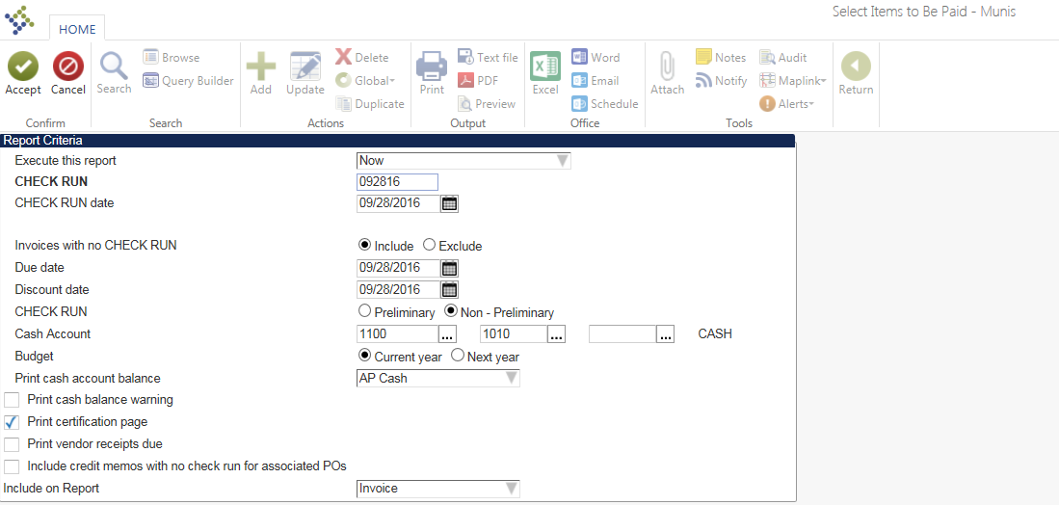

- Click Define, and fill out the fields as defined below:

Field | Description
Execute this report | Select Now to print the report now, or Later (In Background) or at a Scheduled Time to use the Munis Scheduler® for generating the report at a later time.
Warrant | Enter the Check Run number that you used on your invoice batch header here.
Warrant Date | This will default to today’s date, but can be overridden.
Invoices with no Warrant | Select Include or Exclude to include or exclude invoices with no warrant in your find set. The default is Include.
Due Date | Enter an appropriate due date, or leave the default.
Discount Date | Enter an appropriate discount date, or leave the default.
Warrant | Select Preliminary or Non-Preliminary. The default is Preliminary. Selecting Non-Preliminary only allows you to display a list of invoices selected for payment, but not to process. The default is Non-Preliminary.
Cash Account | Select the same cash account that you selected on your invoice batch header.
Print Cash Account Balance | Select None, AP Cash, or Expense Fund. The default is AP Cash.
Print Cash Balance Warning. | Check this box to print a cash balance warning on the report.
Print Certification Page | Check this box to print a pre-defined certification page on the report. The certification text needs to be defined in the Accounts Payable settings before you can print the certification page.
Print Vendor Receipts Due | This check box directs the program to cross-check accounts payable to delinquent vendors.  When this check box is selected, the report includes the vendor, customer, amount owed, AR category/code, bill due date, and bill number.
Include Credit Memos | When this check box is selected, the program examines each invoice in the check run with an associated purchase order for credit memos with a blank warrant number. The program includes these credit memos in the check run.
Include On Report | Select Document, Invoice, or Both. The default is Document.

- Click Accept .
- Click Select to display a list of all invoices in your find set. Notice that the credit memo is displayed with a negative amount. With each invoice that is processed for the vendor, the amount of the credit memo is reduced accordingly. The credit memo will remain within the Select Items to Be Paid program until the amount of the credit has been fully depleted.

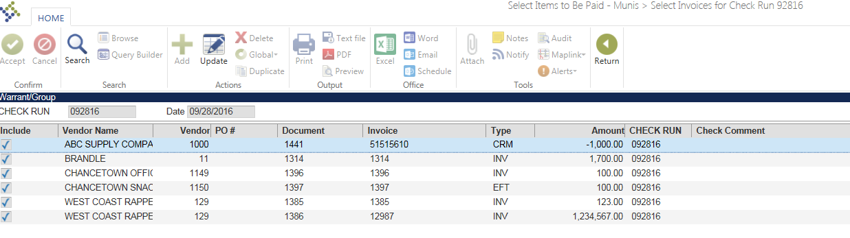

Results
After the credit memo has been posted, it will be located in the Select Items to Be Paid program as shown above. When new invoices for the same vendor are entered, the amount of the credit will be deducted from the invoice amount, and the amount on the credit memo will be reduced accordingly. The credit memo will stay within the Select Items to Be Paid program until the entire credit has been depleted.

GL Impact
A journal entry is posted to the General Ledger that credits the expense account on the credit memo. If the same GL account is used as on the original invoice, this journal will reverse the entries made by posting the original invoice.

Other Munis Modules Impact
This process does not affect other Munis modules.

What’s Next?
Invoices against the same vendor can be entered and the credit entered can be applied to these invoices.

