Invoice Entry - Partial PO/Contract Liquidation

Objective
This document provides instructions on how to enter an invoice that partially liquidates a purchase order or a contact.

Overview
When you choose to enter an invoice against a purchase order or contract with in Munis, you are relieving existing encumbrances to recognize actual expenses. The purchase order or contract amount can retain encumbrance amounts and be used throughout the fiscal year for multiple payments provided the total amount of the encumbrance on the purchase order or contract is not exceeded. An increase to a purchase order’s or contract’s encumbrance will require purchase order or contract maintenance on the original encumbrance.

Invoice batches will be created and submitted on a daily basis. Upon entry of an invoice, the amount allocated to each general ledger (GL) account will appear as a memo balance, which subtracts the net amount from the remaining available budget without displaying supporting invoice detail information when reviewing the account. The invoice will be released through an approval process driven by the accounts contained within the transaction. Upon completion of the approval process, the invoice will be posted and the invoice can potentially be included within the next check run.

Prerequisites
Before you can successfully complete this process, you must ensure that roles granting the necessary permissions have been assigned to your user account. If the roles have not been established, contact the system administrator to have them updated or added into the Munis system.

Confirm the following:

You have access to the accounts to which the invoice will be allocated.
A purchase order or contract against which the invoice is to be paid exists.
PO or contract receiving records have been entered by the individual departments.
The Accounts Payable Invoice Workflow process is established.

Procedure
Complete the following steps to enter an invoice against purchase order lines in Munis:
- Open the Invoice Entry program.
Financials >Accounts Payable > Invoice Processing > Invoice Entry
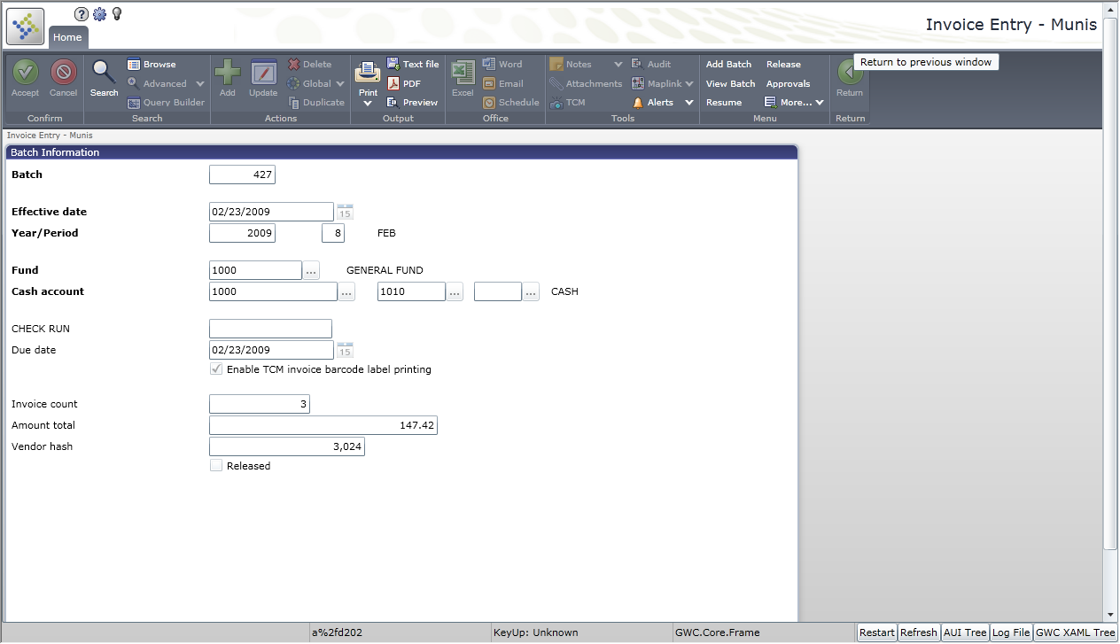
- Click Add Batch.
- Complete the fields according to the following table to define the batch.
Field | Description
Batch | This box identifies the unique number assigned to identify this batch of invoices.  The program automatically assigns the next available batch number according to the default value in the Accounts Payable Settings program, but this can be changed.  The batch number can be reused once a batch has been posted.
Fund | This box specifies the fund to be used with this batch. The program completes this field with the default value entered in the Accounts Payable Settings program.
Cash Account | These boxes display the cash account used to pay invoices in this batch.  The program completes this field with the default value entered in the Accounts Payable Settings program.
Check Run | This box includes the check run number to be assigned to all invoices within this batch. This is a method of grouping invoices to be included in a check run.
Due Date | This box specifies the due date for invoices within this batch. This is another method by which Munis can select to include invoices in a check run. The default value is the current date, but you can change this.
Effective Date | This box specifies the date the invoice affects the general ledger. The default value is the current date, but you can change this.
Year/Period | These boxes define the fiscal year and period for the batch.  The default values are completed according to the General Ledger Settings program, but can be changed with appropriate permissions.
Enable TCM Invoice Barcode Label Printing | This check box, if selected, directs the program to print Tyler Content Manager bar code labels for ease of scanning and attaching printed copies of each invoice.
Invoice Count | This box displays the total number of invoices in the current batch. This is display only.
Amount Total | This box displays the total amount of all invoices in the batch. This is display only.
Vendor Hash | This box contains the vendor hash identifier. This is a reconciliation tool that adds the vendor numbers assigned to each invoice together.
Released | This check box, if selected, indicates whether or not the batch has been released.
Click Accept .

The program displays the Invoice Entry screen.
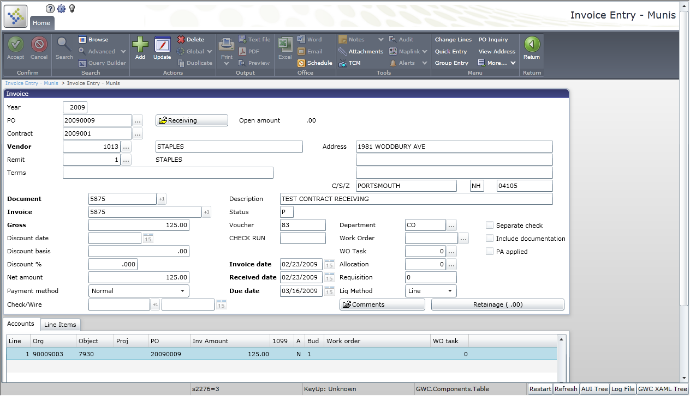
Complete the fields, as required, according to the following table.
Field | Description
Year | This box indicates the fiscal year of the purchase order contract to be liquidated. Valid years are the current or prior year. When the Holding Current Year Open check box is selected in the General Ledger Settings program; valid options include current year and next year.
PO | This box identifies the Munis purchase order number that this invoice is to liquidate. Enter the purchase order number or click the field help button to select a purchase order from a list of open purchase orders.
Contract | This box specifies the Munis contract number, if this invoice is to liquidate a contract. If the PO selected is associated with a contract, the program completes the default value for the contract number.
Vendor | This box identifies the vendor for the invoice. Enter the number or click the field help button to search by Vendor Alpha. The program completes this field according to the information included on the selected purchase order.
Remit | This box identifies the appropriate vendor remittance address. The default remit address displays in the Address fields. Click the field help button to choose from available remittance addresses associated with this vendor.
Terms | This box displays the terms for the purchase. The program completes this value; it is display only.
Document | This box identifies the document number that can be referenced in report and inquiry programs. The program generates the next sequential number as determined by the Accounts Payable Settings program.
Invoice | This box identifies the invoice number as displayed on the invoice.
Gross | This box contains the gross amount of the invoice.
Discount Date | This box specifies the date before which the invoice must be paid to receive the discount percentage entered in the Disc % box. Enter the date or click the calendar button to select a date.
Discount Basis | This box specifies the amount of the invoice that is subject to discount.  This field is only accessible if you enter a Discount Date.
Disc % | This box determines the percentage amount for the discount to be applied to this invoice. This may default from the vendor file.  This field is only accessible if you enter a Discount Date.
Net Amount | This box contains the gross amount of invoice less any discounts applied.
Pay Method | This list identifies the payment method. The program completes this value according to the selected vendor’s preferred method of payment. Available options include direct disbursement, wire transfer, electronic fund transfer (EFT), normal, single check payment, or active card integration (ACI) transfer.  The default value can be changed, if necessary.
Chk/Wire | This box contains the check or wire transfer number if the payment method is a direct disbursement or wire transfer.  Click +1 to assign the next available number.
Check/Wire Date | This date indicates the date of the wire transfer or direct disbursement.
Desc | This box contains the general description; the program completes the default value with the description provided on the purchase order. Enter a brief description to assist the vendor in applying payment.
Status | This box indicates the status of the invoice throughout the approval process. A status of H-Held indicates the invoice must be approved. A status of A-Active means the invoice has been processed.
Check Run | This box indicates which check run in which the invoice will be included. This field is not accessible.
Inv Date | This box identifies the date on the invoice. Enter a date or click the calendar button to select a date.
Rec’d Date | This box displays the date the invoice was received.
Due Date | This box specifies the date the invoice is due.
Dept/Loc | This box identifies the department code associated with this invoice. The program completes the default value with the purchase order department, but you can change this.
Work Order | This identifies a work order number associated with the invoice. Enter a work order number or select the field help button to select an available number, if applicable.  This box applies if your organization uses Munis Work Orders, Fleet and Facilities.
WO Task | This identifies a work order task number, which applies if you have entered a work order number.  This box applies if your organization uses Munis Work Orders, Fleet and Facilities.
Alloc | This box indicates the allocation code associated with the invoice. Enter an allocation code or click the field help button to select a code from a list of available numbers.
Requisition | This box reflects the requisition number from which the selected PO was converted. This field is not accessible.
Liq Meth | This list determines the liquidation method: Line or Account. The program completes the default value according to the Accounts Payable Settings program.
Sep Check | This check box, if selected, indicates that a separate check is required in the event multiple invoices are included for this vendor in a check run. The program will complete this value if this is included on the vendor record or if a one-time pay vendor is selected.
Incl Doc | This check box, if selected, directs that documentation is to be included with the check.
PA Applied | This check box, if selected, indicates that documentation is to be included with the check.
Comments | The Comments button allows you to add or maintain comments for the invoice record.  Only the first line of comments prints on the invoice record.
Retainage | The Retainage button allows you to view, add, or delete current accounts payable retainages that apply to the current invoice.

Press Tab to display the PO Liquidation screen.
The Liquidation by Line screen displays all purchase order or contract lines.
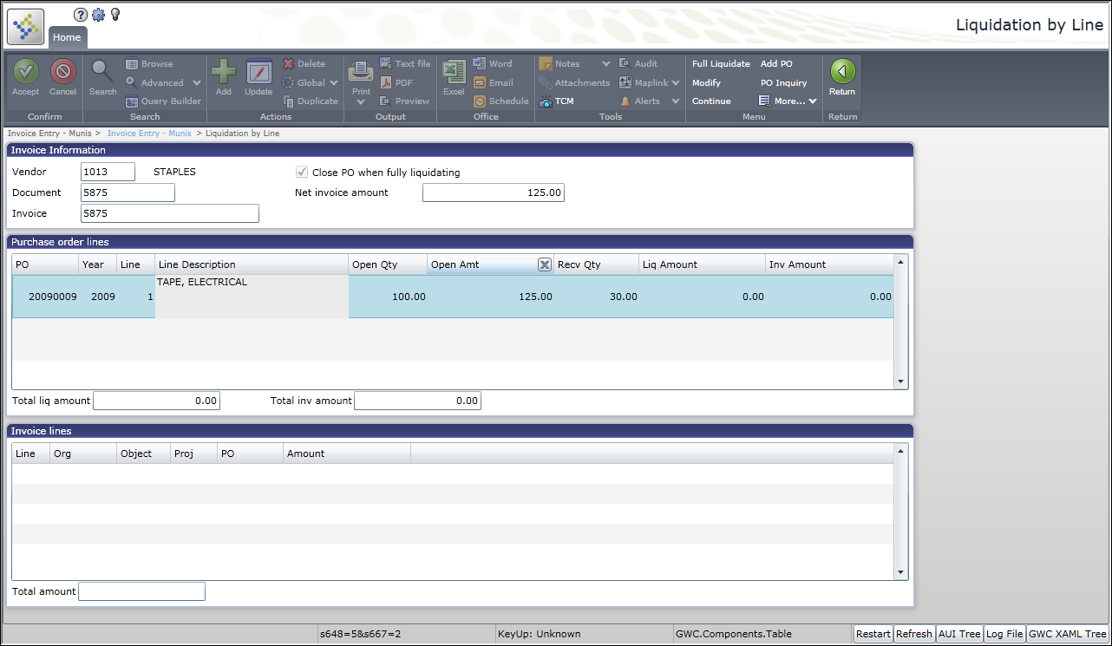
To enter a partial payment, click Modify.
The received quantity displays in the Rec’v Qty column.
Enter the dollar amount to liquidate from each line in the Liq Amount column. Press Tab to move to the Inv Amount column; the program completes the amount to be invoiced based on the liquidation amount entered. Continue until the liquidated and invoice amounts total the invoice amount.
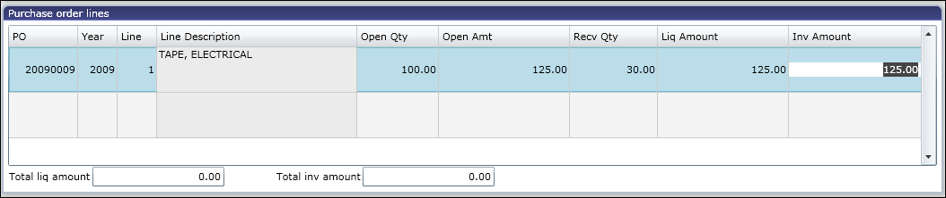
Click Accept .
The program displays the accounts to be charged based on the liquidation and invoice amounts entered in the Invoice Lines group.
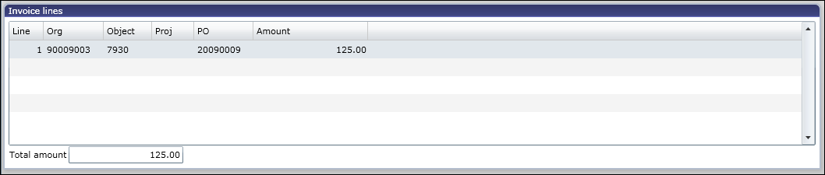
Click Continue to return to the Invoice Entry screen.
Confirm all invoice information, as well as the general ledger accounts to be charged based on the line liquidation selected, is correct.
Click Accept.
The program saves the invoice and displays the Invoice Page Count box.
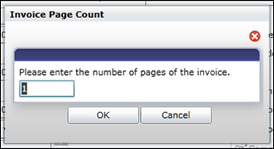
Enter the number of pages for the paper copy of the invoice and click OK. A bar code label will be printed for the invoice added. Affix this label to the printed copy of the invoice. Each invoice will be scanned and attached to the invoice record for online access to the original documentation. The bar code is a reference for Tyler Content Manager to identify the appropriate scanned images to attach to the electronic invoices.
Click Add and repeat the preceding steps to continue adding invoices to the batch. When all invoices are entered, click Return on the Munis ribbon to return to the Invoice Entry Batch Header screen.
Confirm the invoice count and total, as displayed on the header to the invoices ready to be submitted for approval and posting. In the event the batch total or count does not reconcile, click the View Batch option to display a summary list of all invoices within the batch.
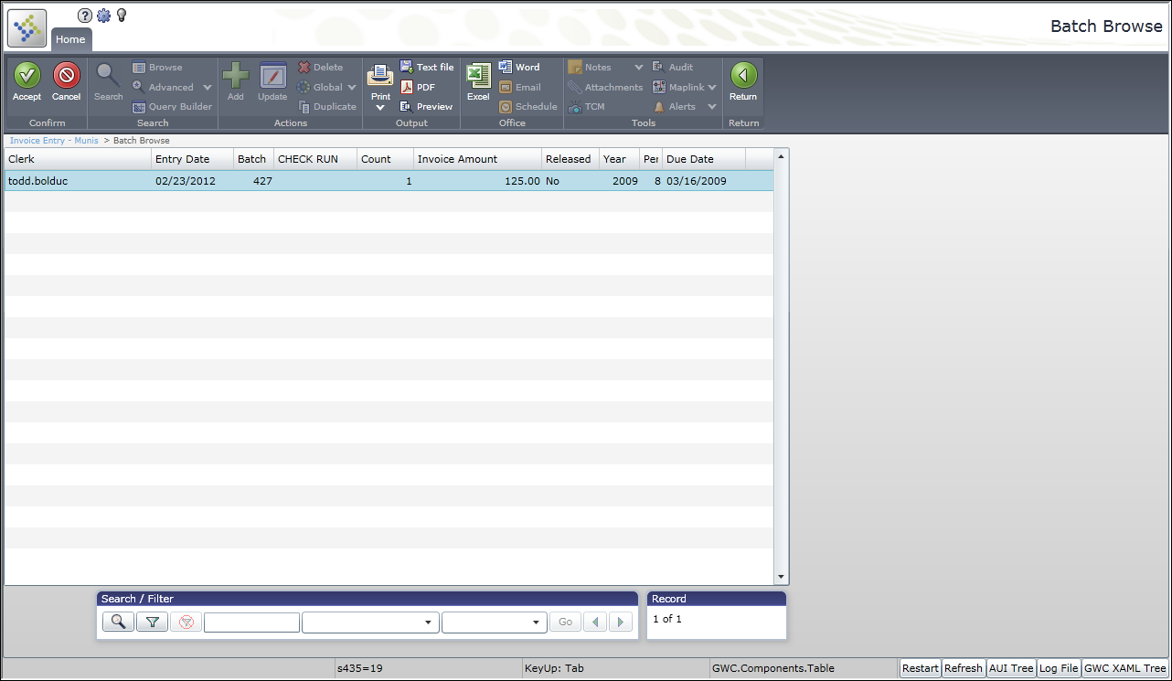
Double-click a record to select it; the program displays it on the Invoice Entry screen.
Update the record, as necessary, and return to the Invoice Entry Batch Header screen.

At any point prior to releasing your batch, you can make changes to the invoices:
- From the Invoice Entry Batch Header Screen, click Resume.
The program displays the Invoice Entry screen.
- Use the navigation arrows at the bottom of the Invoice Entry screen to find the record to modify.
- Click Update and modify the information, as required.
- Click Accept, and then click Return on the ribbon to return to the batch header screen.

When reconciliation is complete, the batch is ready for submission.

To release the batch when reconciliation is complete:
- Click Release.
The Release check box on the Invoice Entry Batch Header screen is selected to indicate the Released status.
- Click Approvals to initiate the approval process.
To view the status of each invoice’s approval process, click Approvers while viewing a record.
The program displays a list of all required approvers, as well as where the action is pending.
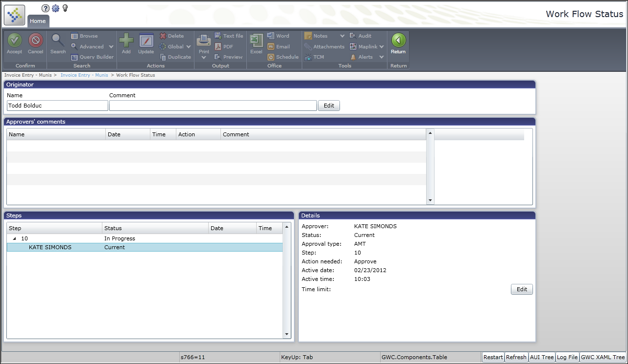

Results
This batch has been released, and the approval process has been initiated. Each record will need to be reviewed and updated by the required approvers. After receiving the required approvals, the invoice will be posted. Once an invoice has been posted, it is no longer available for viewing in the Invoice Entry program. Invoice detail is available from the GL Inquiry, Vendor Invoice Inquiry, Year to Date Budget Reports, and Vendor Central programs.

Status Change
A released invoice has a status of P-Pending indicating it is pending approval. Once the final approver has taken action, this record will be updated to a status of A-Approved. If the invoice does not contain sufficient receiving information, the invoice status will be T-Three Way Match. The invoice remains at this status until adequate receiving records are added.

GL Impact
Upon entry of an invoice, the total amount is reflected in the Actual (Memo) fields for each general ledger account, reducing the available budget.

What’s Next?
Required approvers will receive notification that they have a record pending their approval. The invoices will flow through the approval process until the final step has been completed, at which time the invoice will be posted. Once posted, detail records are available for these transactions under the general ledger accounts affected.

